

**Data Structures and algorithms (CS09203)**

**Lab Report**

Name: Wajih-ul-hassan

Registration #: SEU-F16-151

Lab Report #: 10

Dated: 16-04-2018

Submitted To: Mr. Usman Ahmed

The University of Lahore, Islamabad Campus

Department of Computer Science & Information Technology

**Experiment # 10**

**BFS Graph and its representationsl**

**Objective**

The objective of this session is to show the representation of graphs using C++.

**Software Tool**

1. Code Blocks with GCC compiler.

# Theory

Breadth First Traversal (or Search) for a graph is similar to Breadth First Traversal of a tree. The only catch here is, unlike trees, graphs may contain cycles, so we may come to the same node again. To avoid processing a node more than once, we use a boolean visited array. For simplicity, it is assumed that all vertices are reachable from the starting vertex.

# Task

**2.1 Task 1**

Impement Breadth First Traversal (or Search) for a graph

## Procedure: Task 1

#include*<*iostream*>* #include*<*queue*>* using namespace std ;

struct Node { char data ;

Node ∗ l e f t ;

Node ∗ right ;

};

void LevelOrder (Node ∗root ) { i f ( root == NULL) return ;

queue*<*Node∗*>* Q;

Q. push( root );

while (!Q. empty ()) {

Node∗ current = Q. front (); Q. pop (); cout*<<*current−*>*data*<<*” ”;

i f ( current−*>*l e f t != NULL) Q. push( current−*>*l e f t ); i f ( current−*>*right != NULL) Q. push( current−*>*right );

}

|  |  |
| --- | --- |
| } |  |
| Node∗  } | Insert (Node ∗root , char data ) { i f ( root == NULL) { root = new Node (); root−*>*data = data ;  root−*>*l e f t = root−*>*right = NULL;  }  else i f ( data *<*= root−*>*data ) root−*>*l e f t = Insert ( root−*>*left , data ); else root−*>*right = Insert ( root−*>*right , data ); return root ; |

int main() {

Node∗ root = NULL; root = Insert ( root , ’M’ ) ; root = Insert ( root , ’B’ ) ; root = Insert ( root , ’Q’ ) ; root = Insert ( root , ’Z ’ ) ; root = Insert ( root , ’A’ ) ; root = Insert ( root , ’C’ ) ;

LevelOrder ( root );

}

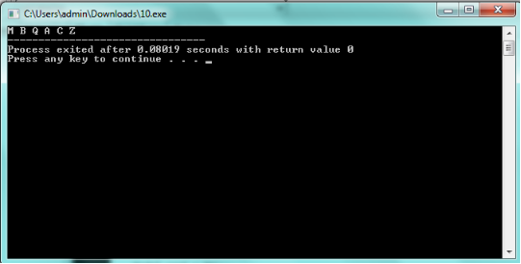

Figure 1: output